**3D-Printing**

Introduction: The aim of this report is to examine 3D-printing. Where it came from, where it is right now and the potential of it.

What is 3D-printing: First introduced in the 1980s by Charles W. Hull, 3D printing is a technology that creates a physical object from a digital model. The process is also called additive manufacturing. In an additive process an object is created by laying down successive layers of material until the object is created. Many different materials can be used for the printing process, the most popular ones are plastic.

What can be done now?

Right now, it is at the point where houses can already be build with a 3D-printer. However these houses are rather small. Since the bigger the house is the bigger the 3D-printer must be. Also, there is a pizza than can be printed by a 3D-printe, however it is unknown how it tastes. There are even parts for spaceships and cars that are produced by 3D-printing.

What can be done in the future?

It is estimated that in the future daily necessities like food, clothes, furniture, cars and other things. Meaning, it will be very comfortable in the future. This too however sinks the workplaces so there may be more unemployed persons in the future. However dangerous things would naturally also be easier to produce if everybody could print whatever they want.

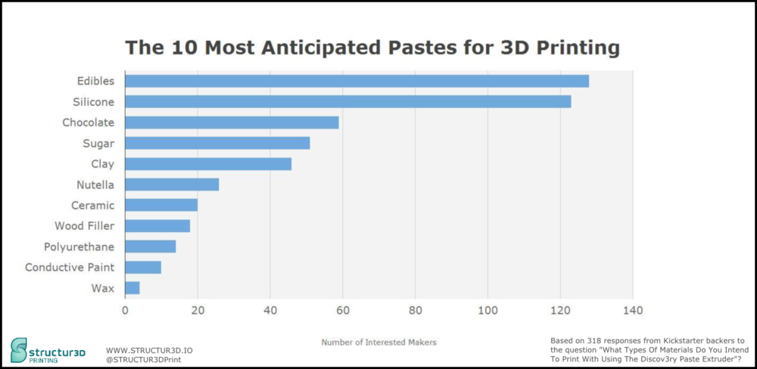

Here we see, that the most anticipated pastes for the future in 3D-printing are edibles followed by a silicone, a material and then again other types of food.

This means that most people are looking forward to being able to 3D-print food.

Conclusion:

3D printing is already a useful technology for science and above all medicine today. In the future, it can take on many more functions and also revolutionize people's everyday lives. However, as with all new technologies, caution is needed as it can easily be misused by others for crimes.